
Department of Computer and Communication Engineering

LAB REPORT
Experiment No : 01
Experiment Name : Installing graphics.h (WinBGIm) in Code::Blocks

Course Title : Computer Animation and Game Development Sessional
Course Code : CCE - 3606

Submitted By
Name : Kazi Sultana Sunehra
ID No : E231413
Semester : 5th
Section : 5AF

Date of Experiment: 08. 09. 2025
Remark
Date of Submission: 22. 09. 2025

Submitted To
Md. Warid Bin Azad
Adjunct Faculty, Dept. of CCE, IIUC



Experiment No: 01

Experiment Name: Installing graphics.h (WinBGIm) in Code::Blocks

Using TDM-GCC Compiler (Step-by-Step Guide):

Step 1: Install TDM-GCC

- Visit: https://jmeubank.github.io/tdm-gcc/
- Download MinGW.org based TDM-GCC 10.3.0 (tdm-gcc-10.3.0.exe, ~60 MB)
- Run installer: Uncheck update option - Select Create → Next → Install
- Default installation directory: C:\TDM-GCC-32
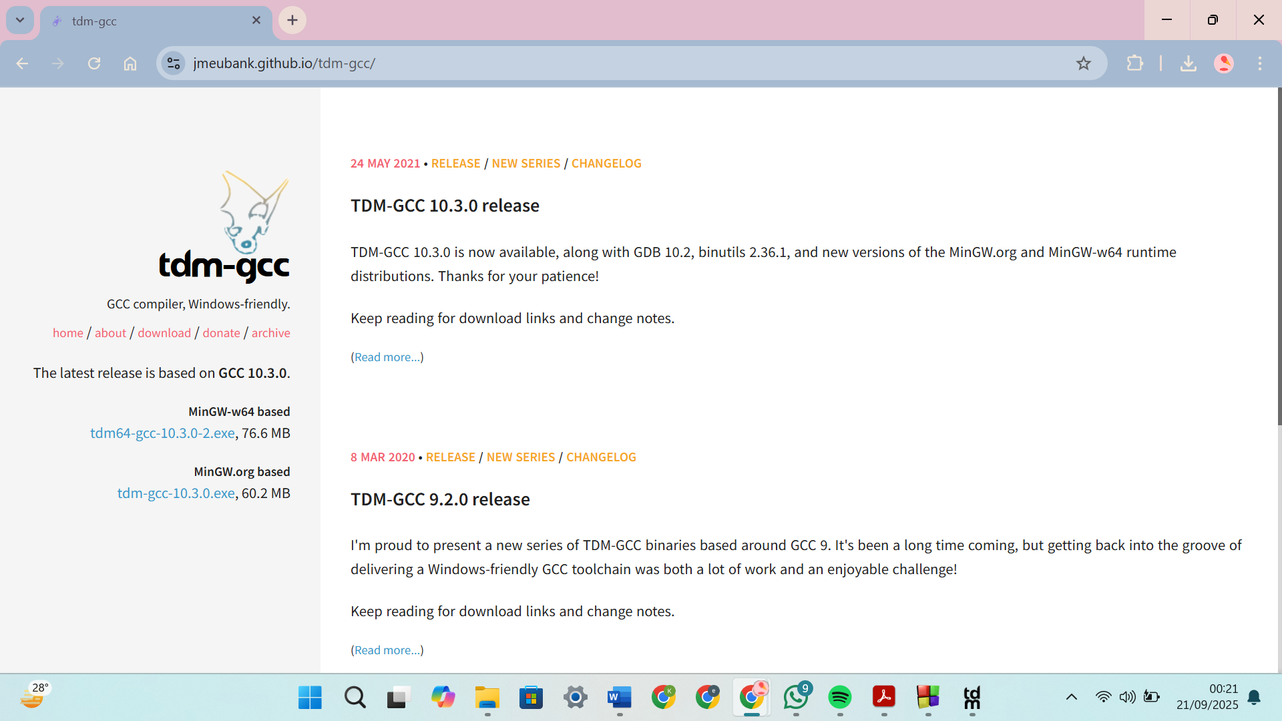
Figure – 01: Download TDM-GCC 10.3.0

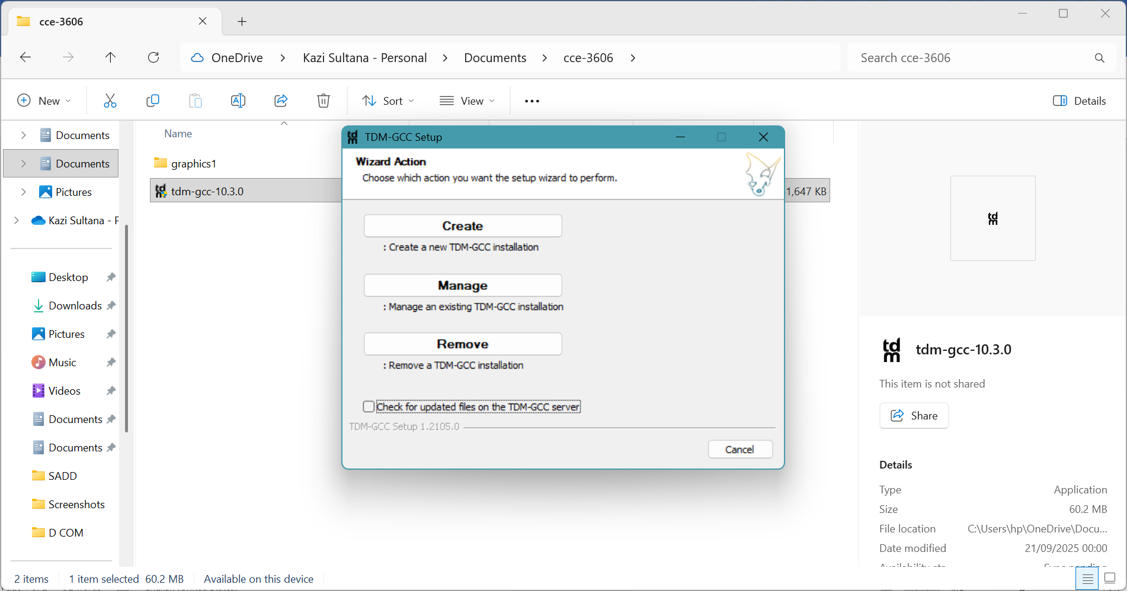
Figure – 02: Run Installer
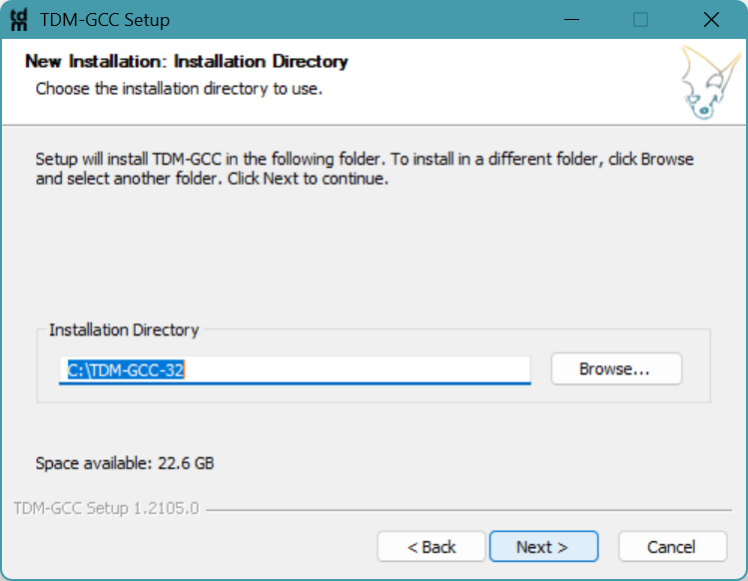
Figure – 03: Set Default Installation Directory

Step 2: Download & Extract WinBGIm
- Download graphics package: https://drive.google.com/file/d/16xZBvFXf7yFjxwTpuyevK1KPuLgUeZFh/view
- Extract contents (should include):
  - graphics.h
  - winbgim.h
  - libbgi.a
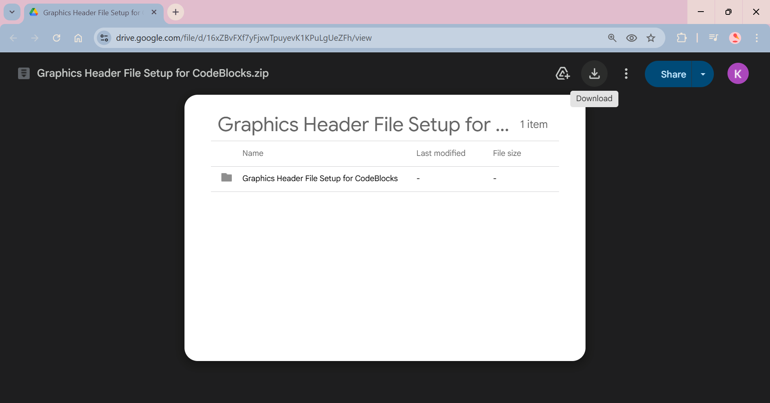
Figure – 04: Download Graphics Package
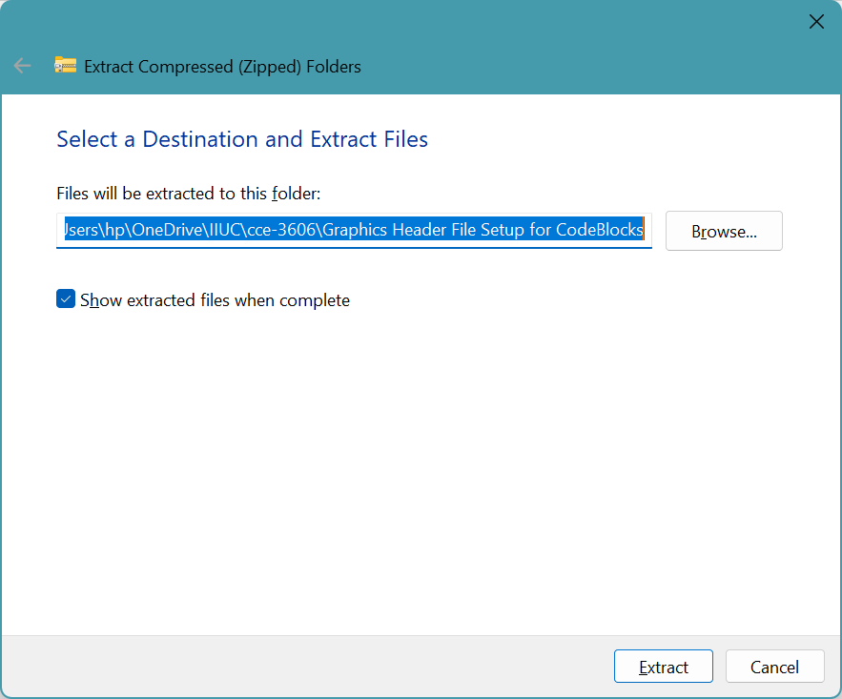
Figure – 05: Extract Contents

Step 3: Place Header and Library Files
- Copy graphics.h and winbgim.h → C:\TDM-GCC-32\include
- Copy libbgi.a → C:\TDM-GCC-32\lib
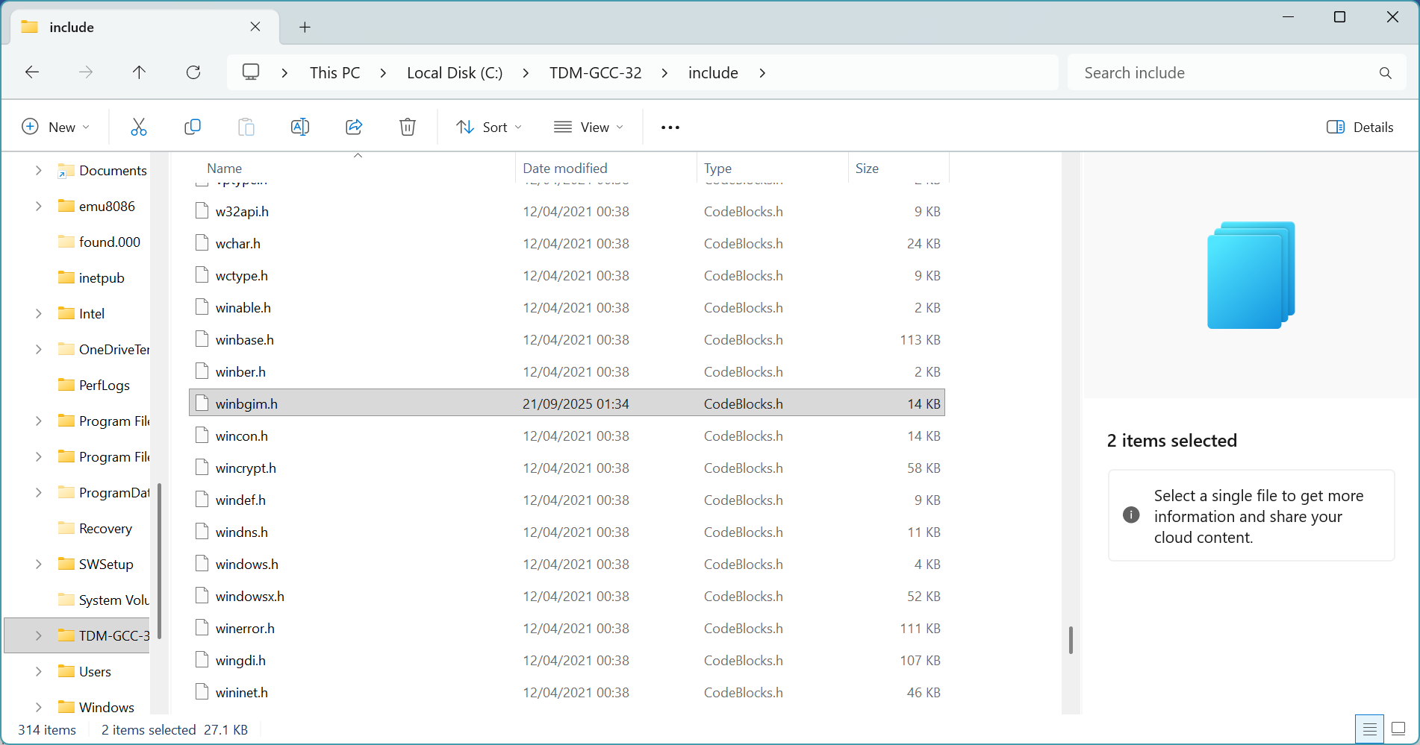
Figure – 6: Copy graphics.h and winbgim.h to C:\TDM-GCC-32\include

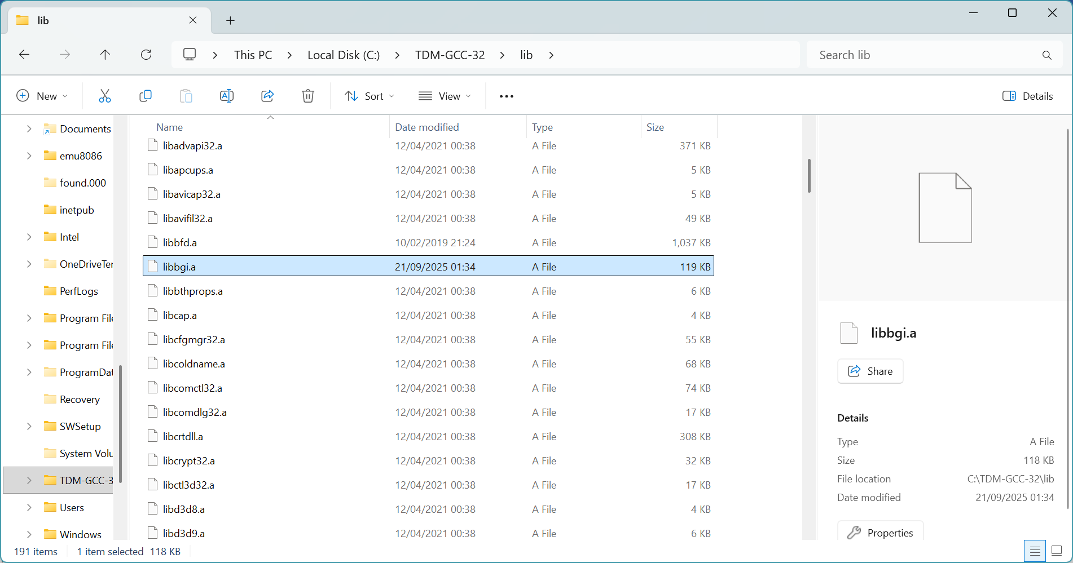
Figure – 7: Copy libbgi.a to C:\TDM-GCC-32\lib

Step 4: Configure Code::Blocks Compiler
- Open Code::Blocks
- Go to Settings → Compiler → Toolchain executables
- Set compiler directory to: C:\TDM-GCC-32
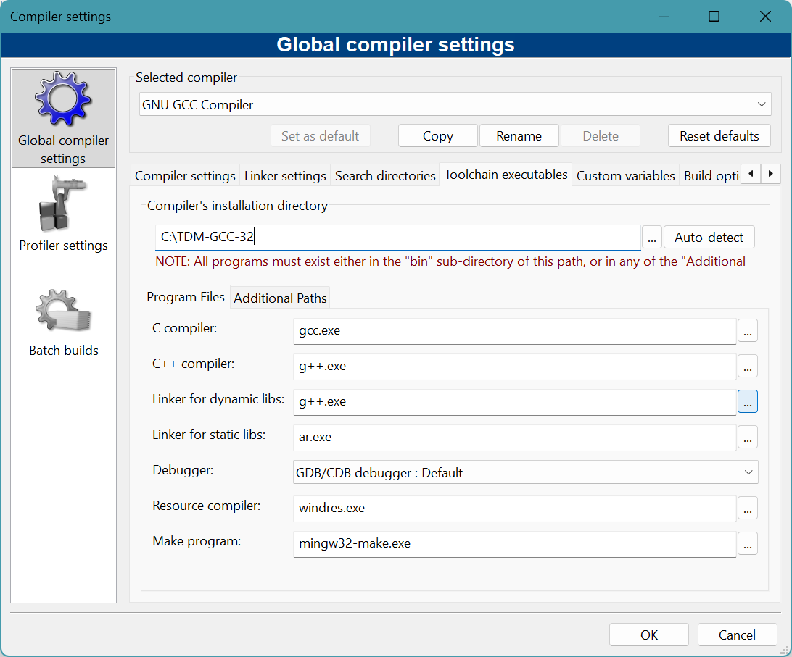
Figure – 8: Set Compiler Directory

Step 5: Configure Linker Settings
- Open Settings → Compiler → Linker Settings
- Under 'Link libraries': Add libbgi.a (from C:\TDM-GCC-32\lib)
- Add the following under 'Other linker options': -lbgi -lgdi32 -lcomdlg32 -luuid -loleaut32 -lole32
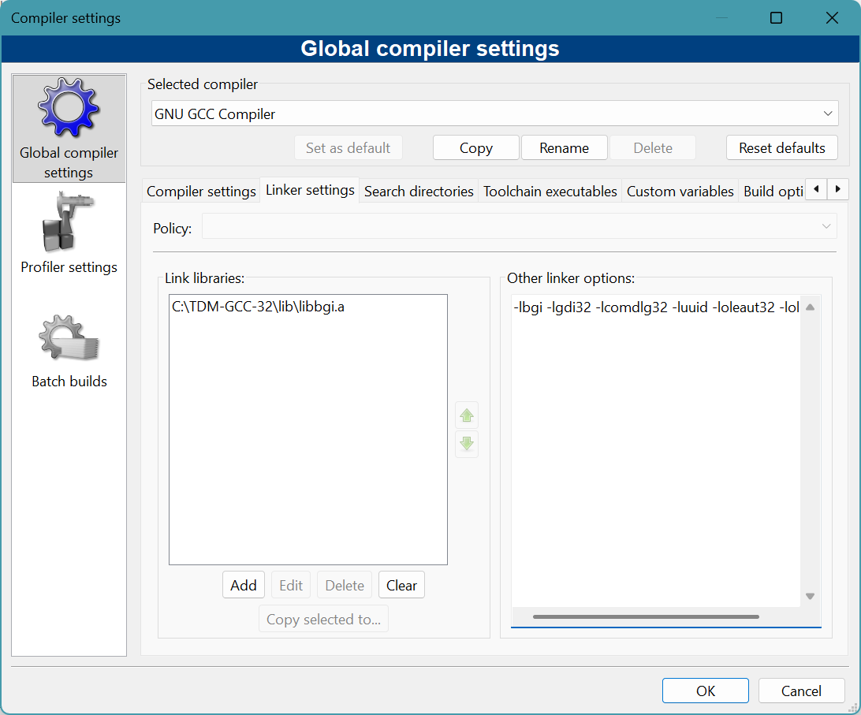
Figure – 9: Configure Linker

Step 6: Use .cpp Extension
• Always save files with .cpp extension
• Using .c may cause errors (e.g., fatal error: sstream: no such file)
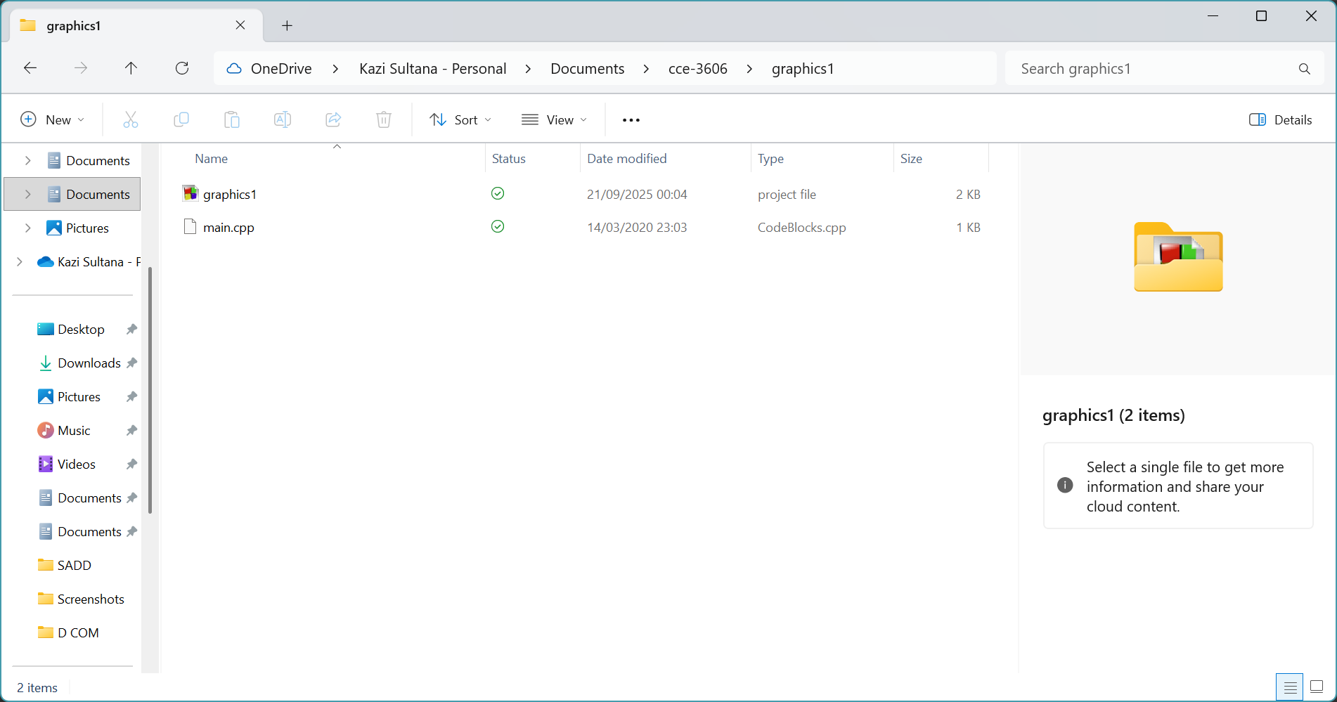
Figure – 10: Save Files with .cpp Extension

Step 7: Verify Setup
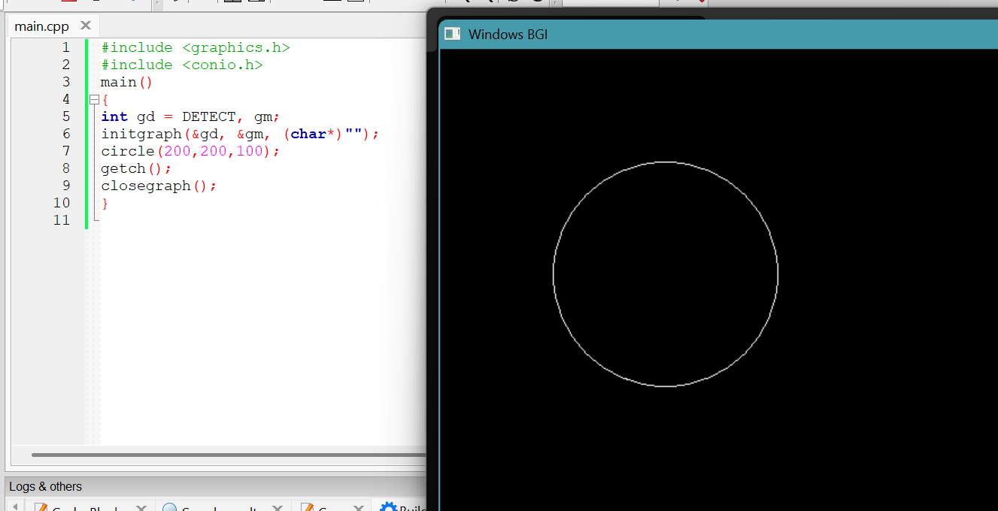
Figure – 11: Source Code and Output

